Rivers, Hail and Flooding huts - The Pouakai Circuit 2020 edition  
28/06/2020 - 30/06/2020

**Attendees:** Anoek Grosmann, Aidan Sarginson, Aiden Leddy, Cheng Kai Jin, Corinna Uhr, Kristina Vitek Parham Alishahi and Shane Maguire

**Written by:** Anoek and Aidan

**Trip plan:**

*Day 1:* Drive to Taranaki and enjoy a short walk to Maketawa hut.

*Day 2:*  Take the sub-alpine route along the Pouakai circuit to the famous Pouakai hut.

*Day 3:* Enjoy the views of the tarns and walk back to the car and drive to Auckland, having enjoyed nature and an escape from lockdown.

**What actually happened:**

*Day 1:*

As we arrived at Taranaki, the heavens opened up, and what did it present? Not sunshine and rainbows, no, what it presented was the brewing storm that had been forecast in the region for the next few days. We put our packs and rain jackets on inside the visitors center, we were then warned by the DOC worker, who was behind the desk all dry and warm that we may have to turn back if the Ngatoro stream had become flooded.

For some reason, we pushed on down the Maketawa track, the rain ever getting heavier. We made it to the river, and to our luck, it hadn’t gotten flooded. Yet... Cue an impromptu river crossing course by Anoek and Aidan (semi-official bush school instructors). After which, we crossed the river and made our way up the ridge. The track gradually became more of a river, the water flowing down onto every next step. We hereby called this torrent on the track ‘The Lake Of Despair’. Finally, Maketawa hut came into view, and we were relieved, and so were the two families inside, who sought pity on us seeing how drenched we all were.

Since we had a small epic making it to the hut, by now Aid**a**n and Aid**e**n already had some healthy rivalry as to who was better Aidan/en. Thus the only way to settle this was to have a cook-off. This involved the planned dinner of nachos and thus there was an epic battle of who could heat up cheese and beans in a pot the fastest. It was close (not really), But Aid**a**n came out on top, being crowned Aidan the first.

After dinner, the only coping mechanism we could think of was Mafia. Eventually, we murdered enough of our own in horrific ways that we had to extend the scheming to the two other families, who happily joined in the chaos. Aidan “the first” took on the role of Narrator, and was inspired to evict group members *cough* killing them *cough* was drowning them in the Lake Of Despair, which became the ritual killing spot for the mafia.

*Day 2:*

Not feeling optimistic about the weather, we reluctantly put on our rain gear and planned to walk to Pouakai hut via a shorter route on the other side of the mountain. We could not walk the same way back to the car, as we were certain that the river was flooded. So, we walked up the ridge only to be hailed on, as the weather gods decided 2020 wasn’t enough on its own already. It was a fun (not) road walk out to the visitors center, where the same DOC worker was stationed, with whom we shared a laugh.

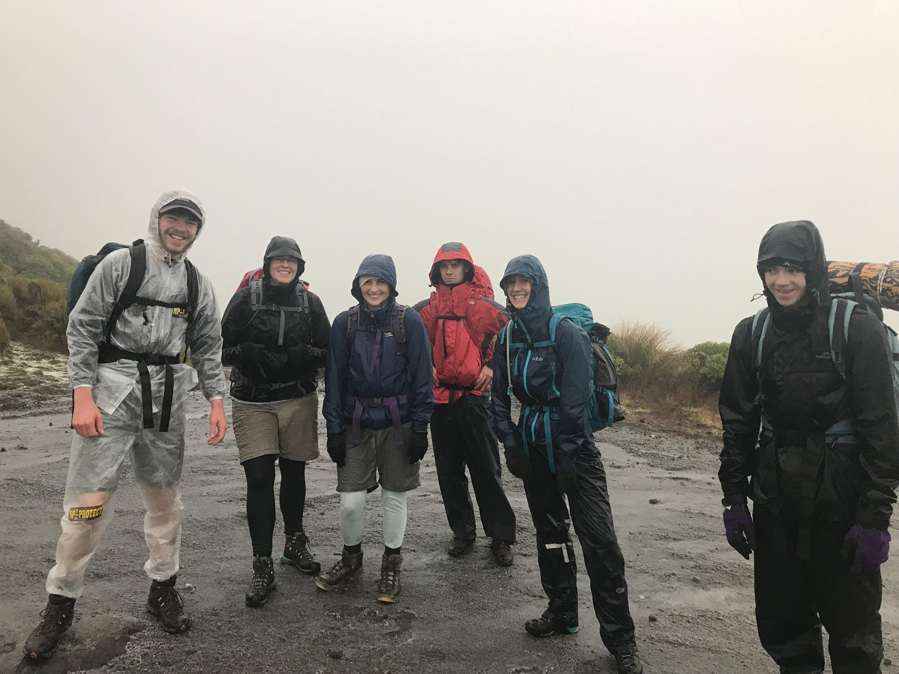

**Figure 1: Back on the road after a good hail shower.**

At the next car park, with one goon box and a few pies and sausage rolls heavier, we enjoyed the very damp but beautiful forest walk up to the hut. Thankfully, this track was wonderfully board-walked for the majority, which almost.. almost.. made up for the weather.

Unfortunately, as this hut is frequented by day walkers, some people left the door to the hut open during the storm. This led to us piling already wet wood as little hopping points across the lake-like floor. The night was filled with more games of Mafia, trying to get dry and our precious goon, which carried us through the night and to the next morning.

*Day 3:*

Wait, I can see a ridgeline? We finally got to enjoy some of those much-advertised views a short walk away at the Pouakai tarns!

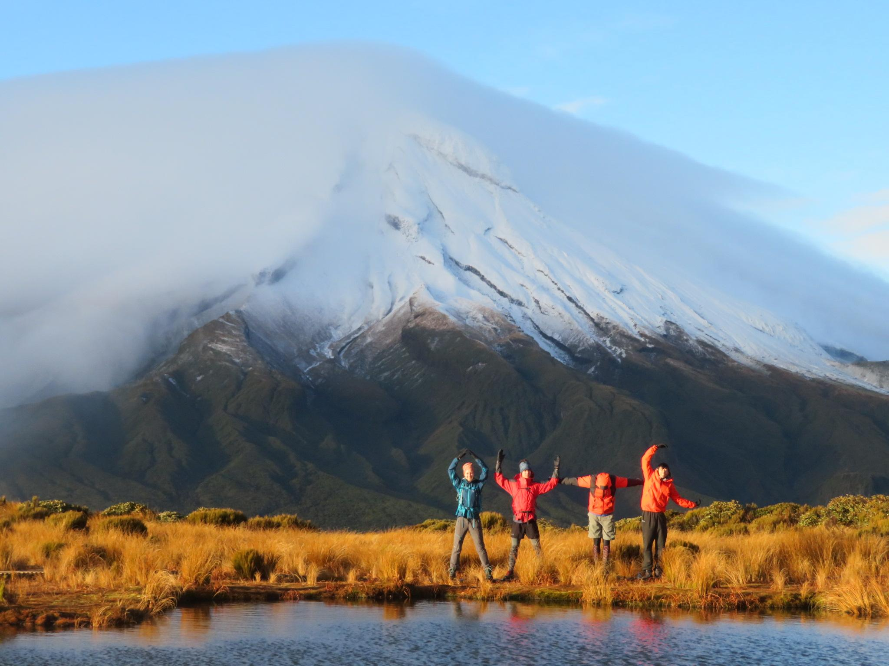

**Figure 2: A classic view with a classic pose**

We then walked back to our cars thinking we could get out nice and early and drive back to Auckland. Of course, it would so happen that we had to wait an hour for CK to be able to open his car, as the torrent of rain and hail and caused his electronic key to stop working.

Overall, we didn’t see much, but we had a great time with new friends. :)

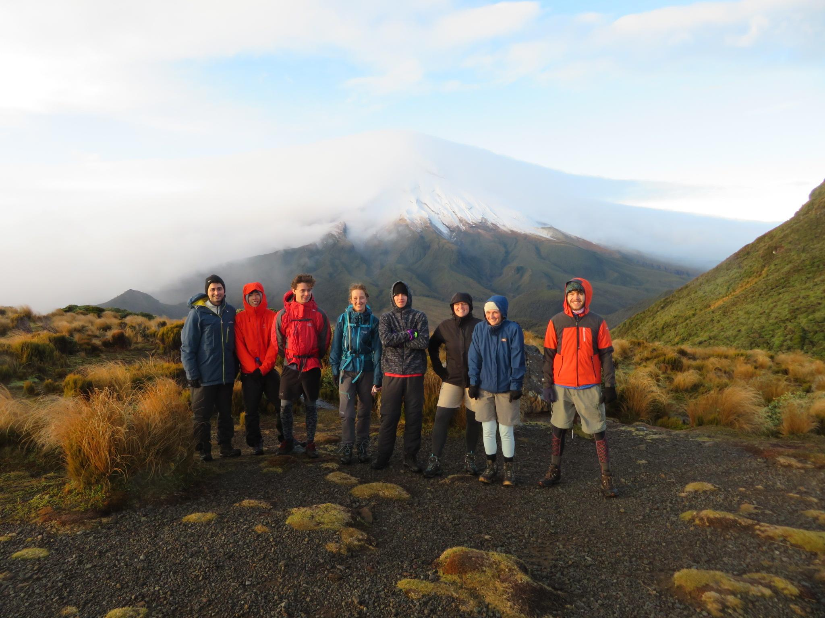

**Figure 3: It’s a view!**

Link for higher quality photos or other ones you think are better: [**https://drive.google.com/drive/u/1/folders/1NJ0poWuoXMeg2MmZbP9sBGsD3nItW13I**](https://drive.google.com/drive/u/1/folders/1NJ0poWuoXMeg2MmZbP9sBGsD3nItW13I)